**Module Title: Digital Marketing Analytics and Social Media**

**Module Code: DGM22704**

Student Name: Edlira Taipi

Student Number: F2411085

**Student ID:24025443**

**Table of Contents**

Part A: Social Media Plan 3

1- Optimised Brand Profile 3

2- Establish Social Media Goals 5

3- Create a Customer Persona 7

4- Complete a Style Guide 7

5- Create 3 pieces of content 8

(i) Awareness Content- Instagram Reel 8

(ii) Interest Content: Instagram Carousel 9

(iii) Loyalty Content: Audio Testimonial I switched to Olive Press? 10

6- Identify and justify 3 Influencers 11

Part B: Report 16

1. Introduction 16

2. Introducing your brand 16

3. What are metrics 16

4. Monitoring and Measuring Metrics 18

5. Social Media Strategy and Performance 19

6. Metrics for your chosen platform and the New Brand 20

7. Conclusion 20

Reference 21

Part A 21

Part B 21

# 

# Part A: Social Media Plan

## 1- Optimised Brand Profile

**Brand Name**: Olive Press

**Social Media Handel (Instagram)**: @onlivepress_green

**Biography**:

* Olive Press
* Pure
* Organic
* Extra Virgin Olive Oil sourced from a sustainable source
* Supporting Local Farmers
* Zero Waste Emission
* Love the Planet; Taste the Tradition; Discover the goodness

**Profile picture**:

**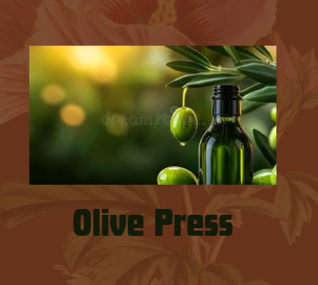  
Figure 1: Profile Picture for Instagram**

(Source: Created by the learner)

**Titles for social media posts or highlights**:

**Social media posts**

* Our Farm
* Sustainability
* Customer Love

**Highlights**

* The Golden Drop: What makes Olive Press special? #sustainability
* Sunkissed Olives Handpicked with love-Taste the difference #cleaneating

## 2- Establish Social Media Goals

|  |  |  |  |  |
| --- | --- | --- | --- | --- |
| **Specific** | **Measurable** | **Achievable** | **Rare** | **Time** |
| **Increasing the followers of Instagram by 20% in 3 months** | This can be based on reaching more than 1000 followers by using reels and story highlights   * **Reels:** 3 posts/week * **Carousels:** 2 posts/week * **Stories:** Daily | This can be measured based on the growing number of followers on Instagram. This will be ensured based on the use of organic content and paid promotions. | Building brand awareness and audience attraction | 3 months |
| **Achieving a 5% average engagement rate over the post on Instagram by the end of the first campaign quarter** | Ensuring active engagement of the consumers based on the posts by tracking likes, comments, shares and saves for each format.   * **Reels:** 5% ER * **Carousels:** 4% ER * **Stories:** 6% swipe-ups/replies | Posting of content is constantly based on the use of user-targeted hashtags. | Retaining consumers and supporting audience interaction | 2 months |
| **Generating 300 website visits month-wise** | Gaining monthly visits of at least 300 consumers based on the use of UTM codes based on swipe-ups, bio links and CTA captions   * **Reels and Carousels:** CTA captions * **Stories:** 6% Swipe-ups/replies | Using swipe-up links, bio-links and CTA posts | To increase the number of sales and interest of the audience | 1 month |
| **Launching of influencer partnerships** | Collaborating with three influencers like one macro, one micro and one nano influencer. | Identifying and approaching micro, macro and nano influencers | Expand the reach and credibility of the page | 2 months |

**Table 1: SMART Objectives for Social Media Management**

(Source: Created by the learner)

## 3- Create a Customer Persona

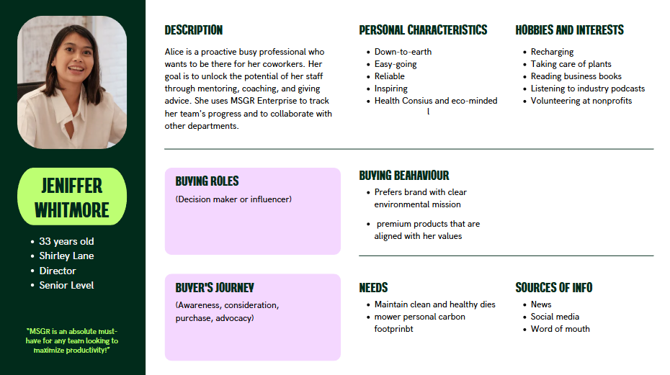

**Figure 2: Customer Persona**

(Source: Created by the learner)

## 4- Complete a Style Guide

**Colours**

The colours that will be used for the posts and the background for the brand include the warm tones of olive green, warm gold, beige, brown and cream white. These colours will provide a premium highlight with a luxe feel while maintaining contrast and clarity.

**Fonts**

The fonts that will be used for the posts, highlights, and stories include Playfair display for the headings and Montserrat for the body of the post. This will provide a traditional yet elegant look while adhering to the modern clean and clarified posting style.

**Aesthetics**

To maintain the aesthetics of the posts, highlights, and stories along with the layout of the profile natural lighting with minimal use of external layout will be maintained. Emojis of earth, leaves and olives will be used with hashtags of sustainability, farm to living and olive.

## 5- Create 3 pieces of content

### (i) Awareness Content- Instagram Reel

**Format**: 30-second Instagram reel

**Title**: ***From Grove to Gold***

**Hashtags**: #ColdPressed, #OliveOilLovers, #SustaibaleFarming, #Behindthescenes, #KnowYourSource

**Description**

In this, a video will be shot highlighting the harvesting and cold pressing process that is being used by Olive Press. The audience will be taken on a visual journey through a sweeping drone, the shots of olive groves, workers handpicking the olives and the oil being bottled in eco-friendly glass containers. The video will be backed by instrumental music that will highlight the main ideation of the video. The video will end with a tagline ***Taste the goodness of golden olives***.

**Goal:** This will make the audience aware of the sustainable sourcing of the raw materials for the preparation of the oil and the sustainability in packaging. It will also highlight the premium nature of the product and the benefits of it being nature-friendly.

**Justification:**

It has been observed that short-term content is more engaging on Instagram in gaining the attention of consumers (Statista, 2024a). The visual narrative will be able to support the athletics guide that has been mentioned earlier like natural lighting along with rustic elegance and warm artisanal tone. The figure below is a post of Dr Hazel Wallace advertising and promoting ***betternaturetempeh*** (a butter) as a source of protein in her Instagram channel.

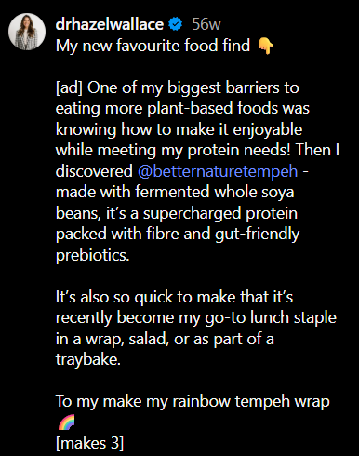

**Figure: Dr Hazel Wallace advertising and promoting *betternaturetempeh***

(Source: https://www.instagram.com/drhazelwallace/reel/C6MQW9NIBp6/)

### (ii) Interest Content: Instagram Carousel

**Format Carousel post with five slides**

**Title**: 3 Ways to Use Olive Press Olive Oil

**Hashtags**: #DailyRituals, #NaturalLiving

* **Slide 1**: Title Slide: Simple 3 Ways to use Olive Press Olive Oil in daily lives
* **Slide 2**: Use 1: Morning Detox
* **Slide 3**: Use 2: Salad Drizzle
* **Slide 4**: Use 3: Hair and Skin glow
* **Slide 5**: CTA: Follow us for healthy living Tips

***Goal***: Educate and engage followers based on providing value-driven content so that the product can be aligned with the daily lifestyle of the population.

**Justification**:

As per the statistics from Statista, it has been observed that the use of Carousels on Instagram can generate more engagement among users in comparison to single images and reels (Statista, 2024b). The Carousels will be able to tap into the interest of the users based on healthy routines, holistic wellness, and beauty. This is a suitable method for engaging the customers as this is made while maintaining an alignment with typography and the colour palette of the brand, as outlined in the style guide. Therefore, it can be said that the intent will serve as the creation of awareness among the active users based on showcasing practical and aspirational usage.

### (iii) Loyalty Content: Audio Testimonial I switched to Olive Press?

**Format**: 1-minute audio clip (Instagram story and Website)

**Title**: ***Why I switched to Olive Press?***

**Hashtags**: #GlowfromWithin, #CleanEating

**Voice-over-script**:

A loyal customer, Jeniffer Whitmore, has shared her valuable insight about switching her olive oil brand in her regular food. “*We put Cool Whip in a bowl and topped it with fresh berries, coconut flakes, and chocolate-covered nuts that we made. Finished it off with Olive Press olive oil and sea salt. Delicious, healthy, and super quick to make*”

**Goal**: This will help reinforce the emotional connection between the brand and the consumer and customer loyalty based on the use of peer validation and social proof.

**Justification**

It has been observed that the use and the presence of user-generated content on the website and the social media pages of the brands help in developing emotional connections with the consumers. It helps in conveying the message of the brand to new and potential consumers. As this comes directly from the audience and the users of the brand, therefore, this helps in maintaining the loyalty of the consumers and value and awareness of the brand in the market.

## 6- Identify and justify 3 Influencers

**Macro Influencer**

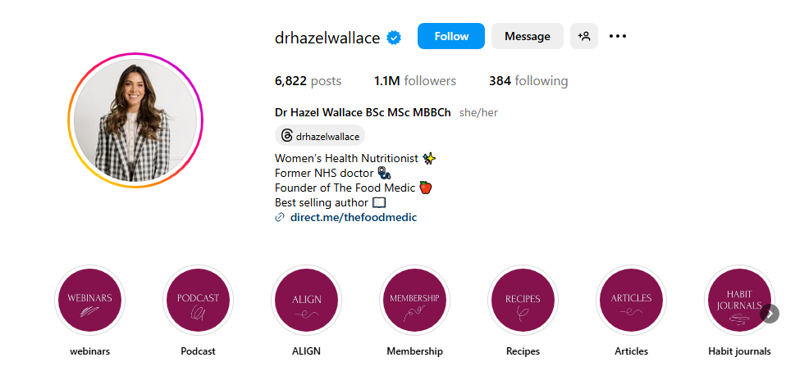

**Figure 3: Instagram Profile of Dr. Hazel Wallace**

(Source: https://www.instagram.com/drhazelwallace/?hl=en)

* ***Influencer Name:*** Dr. Hazel Wallace
* ***Location:*** United Kingdom
* ***Profession:*** Nutritionist, Medical Doctor, and Bestselling Author
* ***Instagram Channel:*** [drhazelwallace](https://www.instagram.com/drhazelwallace/?hl=en)
* ***Followers on Instagram:*** 1.1 Million

***Why is she a Fit?***

Dr. Wallace has several years of medical expertise, along with a passion for nutrition. The uniqueness of Dr. Wallace shares evidence-based wellness advice and healthy recipes with her audiences. Purtle *et al.* (2022) have stated that evidence-based advice is effective in gaining the trust of the audience. Dr. Wallace can influence the audiences of the Olive Press to trust the benefits of its products by showing the relevant evidence. Her credibility and her focus on holistic health can make her an excellent ambassador for Olive Press. She can effectively highlight the benefits of the Olive Press oil on heart health and balanced diets.

***Notable Collaborations***

She has previously collaborated with health focus brands and regularly shares contents that educate her audience on nutritious living.

**Micro Influencer**

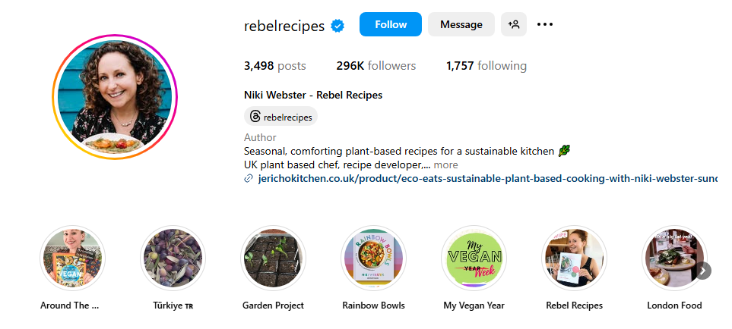

**Figure 4: Instagram Profile of Niki Webster**

(Source: https://www.instagram.com/rebelrecipes/?hl=en)

* ***Influencer Name:*** Niki Webster
* ***Location:*** United Kingdom
* ***Profession:*** Food Stylist, Plant-Based Chef, and Cookbook Author
* ***Instagram Channel:*** [rebelrecipes](https://www.instagram.com/rebelrecipes/?hl=en)
* ***Followers on Instagram:*** 296K

***Why is she a Fit?***

Niki Webster has great specialization in creating vibrant plant-based recipes. Her recipes focus on sustainable and organic ingredients. Her visually appealing content can help to influence the audiences of the Olive Press. Her commitment to health-conscious cooking greatly aligns with the brand ethos of the Olive Press. Kumar *et al.* (2024) have stated that the health consciousness factor is extremely important in the social media campaign to attract customers. Thus, Niki Webster is ideal for showcasing the versatility of Olive Press products.

***Notable Collaborations***

Niki Webster has previously collaborated with reputed brands like Holland & Barrett and Organic UK. She has already showcased her influence in the health food space of the UK.

**Nano Influencer**

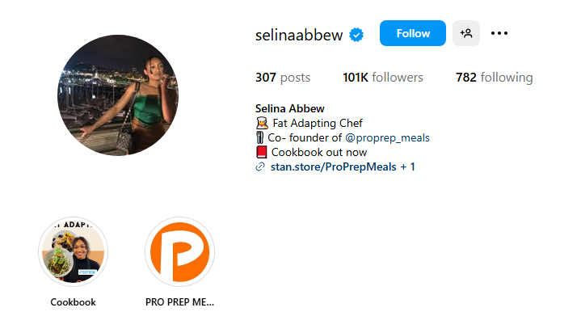

**Figure 5: Instagram Profile of Selina Abbew**

(Source: https://www.instagram.com/selinaabbew/?hl=en)

* ***Influencer Name:*** Selina Abbew
* ***Location:*** United Kingdom
* ***Profession:*** Co-founder of Pro Prep Meals, Chef, and Author
* ***Instagram Channel:*** selenaabbew
* ***Followers on Instagram:*** 101K

***Why is she a Fit?***

Selina Abbew regularly promotes high-fat, low-carb, and gluten-free recipes for her regular audiences. The main focus of Selina Abbew is unprocessed and natural foods. The approach of Selina Abbew to healthy meal preparation and healthy eating resonates with the quality and wellness commitment of the Olive Press towards its customers. Thus, she is a suitable choice for engaging with a niche audience in the UK who are looking for nutritious cooking. Selina Abbew has the potential to influence the audiences of the Olive Press to believe in the benefits of its products. She can efficiently explain all the contents of the products along with influencing customers to buy the products.

**Notable Collaborations**

As Selina Abbew is new in the social media arena, she has started to collaborate with food startups that aim to provide healthy foods to customers in the UK.

# Part B: Report

# 1. Introduction

This report aims to analyse the potential social media and business metrics that will help the proposed business to make informed decisions to effectively measure and monitor its social media strategy. The chosen business is an Olive oil business, and the name of the brand is Olive Press. The particular social media platform that has been chosen for the brand progression is Instagram.

# 2. Introducing your brand

Olive Press will be a premium brand that will emphasise health, authenticity, and sustainability. Ghosh *et al.* (2021) have stated that sustainability initiatives help brands to reach environment-conscious consumers easily. For that reason, sustainability will be one of the main aspects of this brand. It will focus on offering extra virgin and cold-pressed olive oil directly sourced from the Mediterranean grove. The nutritional value and purity of the olive oil will be maintained in the final product. The main targeted customers of the Olive Press will be eco-friendly individuals, health-conscious customers, and food enthusiasts. The individuals who prefer ethical sourcing and value quality ingredients should be targeted in the social media campaigns (Ghosh *et al.*, 2021). The brand’s primary function will be to provide top-tier olive oil for wellness and culinary purposes. Instagram will be used to share visually appealing content, including behind-the-scenes harvesting videos, wellness educational posts, and recipe ideas. The customers will be engaged through regular stories and reels on the Instagram channel.

# 3. What are metrics

|  |  |
| --- | --- |
| **Metrics** | **Progress Measurement Criteria** |
| **Engagement Rate** | Likes, Shares, Comments, and Saves (Mothapo *et al*., 2024).  Benchmark: 500 likes, 30 shares, 100 comments per post weekly |
| **Reach and Impression** | Total views of each content and the number of unique users (Yang and Zhai, 2022).  Benchmark: 2000 views per post weekly |
| **Follower Growth** | How quickly the Instagram account is gaining new followers (Yang and Zhai, 2022).  Benchmark: 100 new followers on instagram per week |
| **Click-Through Rate** | The number of clicks every second on the bio and story links (Farris *et al.*, 2021).  Benchmark: 5 clicks per post every minute |
| **Conversion Rate** | The real number of users who purchase the product or sign up for the newsletter (Mothapo *et al*., 2024).  Benchmark: 20 real users per week |

**Table 1: Metrics and Progress Measurement Criteria**

(Source: Created by Learner)

The performances of the campaigns and social media content are tracked, measured, and evaluated through the quantitative measure called Metrics (Mothapo *et al*. 2024). These data points are used by businesses to understand the growth of online activities. Olive Press will use five metrics to monitor its growth on Instagram, which include Engagement Rate, Reach and Impression, Follower Growth, Click-Through Rate, and Conversion Rate. These metrics will be used by the Olive Press to monitor the audience interest and Return on Investment (ROI). The follower growth can be assessed to measure the potential customers that are being attracted by the social media post. These potential customers can be converted into real customers to increase the ROI. The engagement rate will be checked weekly. The click-through rate and conversion rate can be checked monthly. The ROI will be compared with the investment to implement these metrics.

# 4. Monitoring and Measuring Metrics

**“Explain and expand on the importance of metrics.”**

Farris *et al.* (2021) have stated that measuring and monitoring metrics are essential to evaluate the success of any brand to reach maximum audiences. Metrics can help to identify the content that can perform best in a week or a month (Farris *et al.*, 2021). Similarly, metrics are also important for the Olive Press to monitor the effectiveness of regular Instagram content to reach wider audiences.

**“How will you monitor and measure them?”**

Engagement metrics will be monitored and measured by checking the number of likes, shares, comments, and saves gathered by each content. Total views of each content can be checked regularly to measure the “Reach and Impression” metric (Farris *et al.*, 2021). Follower growth will be measured by checking the rate at which the Instagram account is gaining new followers every day.

**“What tools will you use?”**

I will use the ***Google Analytics*** tool to measure the proposed metrics. Gkikas and Theodoridis (2024) have stated that Google Analytics is effective for measuring the traffic on the social media platform, along with evaluating sales conversions. I will also use the ***Instagram Insights tool*** to track post engagement, performance, and reach. Along with it, ***Meta Business Suite*** will also be used for managing content schedules.

**“How will they demonstrate the success of your marketing campaign?”**

The success of future marketing strategies on Instagram can be demonstrated by the real-time feedback (Drivas *et al.,* 2022). Ambasht (2023) has stated that real-time statistical feedback is essential to make data-driven decisions. Ambasht (2023) also mentioned that content that can show a high amount of engagement can be repeated consecutively with certain modifications and fresh input.

# 5. Social Media Strategy and Performance

**“Discuss your Social Media Strategy and how it will assist your brand.”**

Olive Press will focus on building a strong visual identity through its social media content. The audience can be educated about the benefits of using the products, along with fostering community interaction (Yang and Zhai, 2022). On most of the Instagram posts, visually appealing pictures of the Olive oil extraction process will be showcased.

**“What metrics and analytics will you use?”**

The metrics that will be focused on are Engagement Rate, Reach and Impression, Follower Growth, Click-Through Rate, and Conversion Rate. Analytics like Google Analytics, Instagram Insights, and Meta Business Suite will be used to track these metrics.

**“How will you measure your performance?”**

Drivas *et al.* (2022) have stated that engagement rate can be effectively measured by the regular interactions and story views on social media platforms. Thus, several story views, figures, and Instagram messages will be counted to measure the performance of the campaign. The brand's popularity will be measured by follower growth rate.

**“How does this help you meet your Social Media Goals?”**

This strategy will help the Olive Press to meet its social media goals by increasing brand awareness. Huang *et al*. (2023) have mentioned that social media campaigns are effective in building a loyal online community. Thus, these strategies will help boost product sales by creating a loyal online community.

# 6. Metrics for your chosen platform and the New Brand

**“Discuss what the most important analytics for your brand are and how you will use them.”**

Yang and Zhai (2022) have stated that the Click-Through Rate (CTR) is an important metric to know how many potential customers are turning into real customers. The Click-Through Rate (CTR) metric can be used to measure how many social media users are buying the products (Yang and Zhai, 2022). The Follower Growth Rate will also be checked to analyse the rate at which the online community is growing. Important Analytics like Google Analytics, Instagram Insights, and Meta Business Suite

**“How do all of these factors fit into my social media plan and the specific content I created?”**

The consistent monitoring of these metrics will help to gain valuable feedback, which will be utilised for optimising the content and improving the targeting strategy. Okeke *et al.* (2024) have stated that customer relationships can be improved by analysing the choices of customers through effective metrics. Thus, a long-term relationship will be created with the customers of the Olive Press through these metrics.

# 7. Conclusion

In conclusion, it can be summarised that metrics like Engagement Rate, Reach and Impression, Follower Growth, Click-Through Rate, and Conversion Rate are effective to monitor the growth and reach of Instagram content and campaigns by Olive Press. However, analytics like Google Analytics, Instagram Insights, and Meta Business Suite are extremely important to track these metrics.

Reference

## *Part A*

*Forbes, 2022. The Rise Of User-Generated Content And Its Impact On Brand Loyalty And Affinity. Available at:* [*https://www.forbes.com/councils/forbesagencycouncil/2022/09/12/the-rise-of-user-generated-content-and-its-impact-on-brand-loyalty-and-affinity/*](https://www.forbes.com/councils/forbesagencycouncil/2022/09/12/the-rise-of-user-generated-content-and-its-impact-on-brand-loyalty-and-affinity/) *(Accessed: 14 April 2025)*

*Kumar, S., Kaur, B. and Goyal, S., 2024. Role of Social Media Health Influencers on Purchase Intention of Functional Beverages: Moderating Impact of Health Consciousness. Information & Media, 99, pp.63-84.*

*Purtle, J., Crane, M.E., Nelson, K.L. and Brownson, R.C., 2022. Disseminating information about evidence-based interventions. Practical implementation science: Moving evidence into action, pp.227-252.*

*Statista, 2024a. Distribution of Instagram content performance worldwide as of July 2022, by content type. Available at:* [*https://www.statista.com/statistics/1328766/global-distribution-of-instagram-content-performance-by-type/*](https://www.statista.com/statistics/1328766/global-distribution-of-instagram-content-performance-by-type/) *(Accessed: 14 April 2025)*

*Statista, 2024b. Engagement rate of brand content on Instagram 2024, by format. Available at:* [*https://www.statista.com/statistics/1496803/instagram-brand-engagement-rate-content-format/*](https://www.statista.com/statistics/1496803/instagram-brand-engagement-rate-content-format/) *(Accessed: 14 April 2025)*

## *Part B*

*Ambasht, A., 2023. Real-Time Data Integration and Analytics: Empowering Data-Driven Decision Making. International Journal of Computer Trends and Technology, 71(7), pp.8-14.*

*Drivas, I.C., Kouis, D., Kyriaki-Manessi, D. and Giannakopoulou, F., 2022. Social media analytics and metrics for improving users engagement. Knowledge, 2(2), pp.225-242.*

*Farris, P.W., Bendle, N., Pfeifer, P. and Reibstein, D., 2021. Marketing metrics: The manager's guide to measuring marketing performance. FT press.*

*Ghosh, S., Mandal, M.C. and Ray, A., 2021. Selection of environmental-conscious sourcing: an empirical investigation. Benchmarking: An International Journal, 28(6), pp.2130-2155.*

*Gkikas, D.C. and Theodoridis, P.K., 2024. Predicting Online Shopping Behavior: Using Machine Learning and Google Analytics to Classify User Engagement. Applied Sciences, 14(23), p.11403.*

*Huang, T.K., Wang, Y.T. and Lin, K.Y., 2022. Enhancing brand loyalty through online brand communities: the role of community benefits. Journal of Product & Brand Management, 31(5), pp.823-838.*

*Mothapo, M., Thango, B. and Lerato, M., 2024. Tracking and Measuring Social Media Activity: Key Metrics for SME Strategic Success-A Systematic Review. Available at SSRN 4992468.*

*Okeke, N.I., Alabi, O.A., Igwe, A.N., Ofodile, O.C. and Ewim, C.P.M., 2024. Customer journey mapping framework for SMEs: Enhancing customer satisfaction and business growth. World Journal of Advanced Research and Reviews, 24(1).*

*Yang, Y. and Zhai, P., 2022. Click-through rate prediction in online advertising: A literature review. Information Processing & Management, 59(2), p.102853.*